**CRISPR cas9 mediated knockout (KO) HAP1 cells**

1. **Design guide sequence oligos using Benchling**
2. Open Benchling and choose the + sign option and select Design crispr guides
3. Add your gene ID (for example here it is DGS2 human)
4. Select GRCh38 (hg38 homosapiens) (HG38 and HG19 refer to the version of the build. In general, it is best to use the newest version (HG38) so you can work with the most up-to-date information)
5. Then choose single guide, followed by PAM sequence choose NGG
6. FINISH, then in sequence map chose your desired Exons for targets
7. Check for better Off target and on target scores and then choose your vector PX458 (WT-2A-EGFP 48138) Then assemble will give you the both top and bottom strands
8. **Oligos used for DSG2 KO**
9. Exon 3

Forward (sgRNA TOP) CACCGCGCCTGGATCACCGCCCCCG

Reverse (sgRNA BOTTOM) aaacCGGGGGCGGTGATCCAGGCGC

1. Exon 5

Forward (sgRNA TOP) CACCGGTTACGCTTTGGATGCAAG

Reverse (sgRNA BOTTOM) aaacCTTGCATCCAAAGCGTAACC

1. Exon 8

Forward (sgRNA TOP) CACCGACAGATGCTCAAACTAACGA

Reverse (sgRNA BOTTOM) aaacTCGTTAGTTTGAGCATCTGTC

1. Exon 2

Forward (sgRNA TOP) CACCGATCTGCTTTAACGTTGGAAG

Reverse (sgRNA BOTTOM) aaacCTTCCAACGTTAAAGCAGATC

1. **Cloning sgRNA into the PX458 (WT-2A-EGFP 48138)**
2. *Preparation of the sgRNA oligos inserts.* Resuspend the top and bottom strands of oligos for each sgRNA design (Step 1) to a final concentration of 100 μM. Prepare the following mixture for phosphorylating and annealing the sgRNA oligos (top and bottom strands)

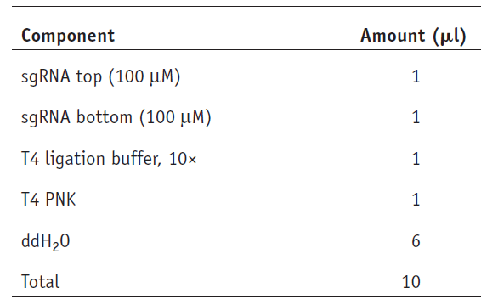

1. Phosphorylate and anneal the oligos in a thermocycler by using the following parameters: 37 °C for 30 min; 95 °C for 5 min; ramp down to 25 °C at 5 °C min−1.

I used T7 Ligase NEB instead of T7 ligase with 2x rapid ligation buffer (cat no L602L)

Also, I used T4 DNA ligase buffer from fermentas instead of T4 DNA ligase 10x NEB M0201S

1. *Cloning the sgRNA oligos into pSpCas9(BB).* Set up a ligation reaction for each sgRNA, as described below. We recommend also setting up a no-insert, pSpCas9(BB)-only negative control for ligation

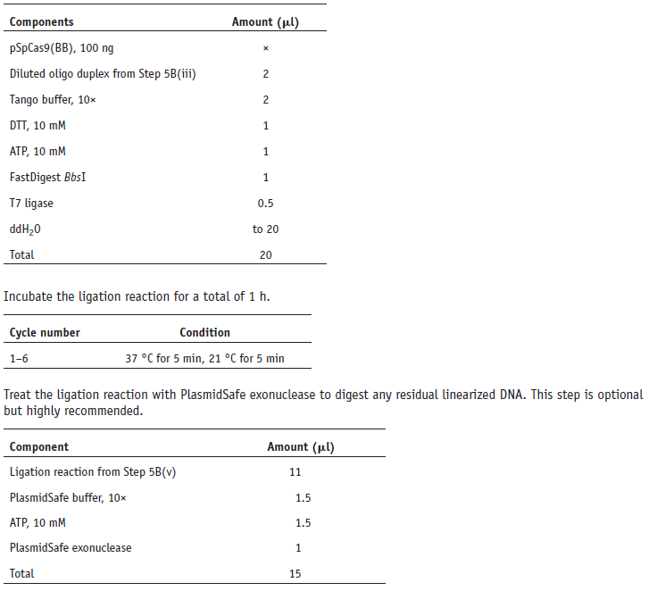

I used the plasmid safe step to avoid the self-ligated plasmid without insert.

1. Incubate the PlasmidSafe reaction at 37 °C for 30 min, followed by 70 °C for 30 min. PAUSEPOINT After PlasmidSafe treatment, the reaction can be stored at −20 °C for at least 1 week.
2. *Transformation.* Transform the PlasmidSafe-treated plasmid into a competent *E. coli* strain, according to the protocol supplied with the cells. We recommend the Stbl3 strain for quick transformation. Briefly, add 2 μl of the product from Step 5B(vii) into 20 μl of ice-cold chemically competent cells borrowed from Annas lab(DH5 alpha), incubate the mixture on ice for 10 min. plate it onto an LB plate containing 100 μg ml−1 ampicillin.
3. Incubate it overnight at 37 °C. Note that it is not necessary to incubate competent cells for the outgrowth period after heat shock when you are transforming ampicillin-resistant plasmids.
4. Inspect the plates for colony growth. Typically, there are no colonies on the negative control plates (ligation of BbsI-digested pSpCas9(BB) alone without annealed sgRNA oligo insert), and there are tens to hundreds of colonies on the pSpCas9(sgRNA) (sgRNA inserted into pSpCas9(BB)) cloning plates.
5. From each plate, pick two or three colonies to check for the correct insertion of sgRNA. Use a sterile pipette tip to
6. inoculate a single colony into a 3-ml culture of LB medium with 100 μg ml − 1 ampicillin. Incubate the culture and shake it at 37 °C overnight.
7. Isolate the plasmid DNA from cultures by using a QIAprep spin miniprep kit according to the manufacturer’s instructions.
8. Sequence validation of CRISPR plasmid. Verify the sequence of each colony by sequencing from the U6 promoter using the U6-Fwd primer.
9. Maxipreps of the verified clones were done and used for the transfection experiemnts .
10. **Functional validation of sgRNAs: HEK 293T cell culture and transfections**
11. HEK293T/HAP1 cells were seeded in six well plates and performed transfection using the Genejuice (MERCK)
12. Seed 50-100,000 cells/ well, add
13. The day before transfection, plate 1–3 × 105 cells in complete growth medium per well of a 6 well plate. Incubate at 37°C (5% CO2) overnight.
14. Cells should be 50–80% confluent before transfection. Note: For most cell lines, the optimal ratio of GeneJuice
15. Transfection Reagent to DNA is 3 µl reagent to 1 µg DNA. However,the ratio can be varied from 2–6 µl per µg DNA during optimization.
16. For each well to be transfected, place 100 µl serum-free medium into a sterile tube. Add 3 µl GeneJuice
17. Transfection Reagent drop-wise directly to the serum-free medium.
18. Volumes can be scaled up for transfection of multiple wells with the same DNA.
19. Mix thoroughly by vortexing.
20. Incubate at room temperature for 5 min.
21. For each well to be transfected, add 1 µg DNA to GeneJuice Transfection Reagent/serum-free medium mixture. Mix by gentle pipetting. Do NOT vortex.
22. Incubate GeneJuice Transfection Reagent/DNA mixture at room temperature for 5–15 min.
23. Add entire volume of GeneJuice Transfection Reagent/DNA mixture drop-wise to cells in complete growth medium. Distribute drops over entire surface of dish.
24. Gently rock dish to ensure even distribution.
25. Do not swirl plate, as doing so will concentrate transfection mixture in center of plate. I
26. Incubate cells for 24–72 h at 37°C (5% CO2).
27. Harvest cells for analysis
28. **Isolation of clonal cell lines by FACS**
29. Wash and detach your cells with trypsin.
    * 1. Resuspend cells in PBS supplemented with 2% FBS
      2. Count your cells, centrifuge them (+4˚C) and resuspend in PBS 2 % FBS to a final volume of app. 600 microliters
      3. Keep you cells on ice
      4. Just before you will sort you cells, filter them through a 70µm filter (to ensure single cells, I will give you the filter!) and rinse the filter with an additional 200 mikroliter everything should go into a FACS tube with lid. Continue to keep the cells on ice.
      5. Prepare a FACS tube with 500 mikroliter of PBS + 10% FBS for the cells to be sorted into
      6. Note: Keeping the cells on ice will prevent them from aggregating which otherwise would cause problems with clogging of the cell sorter